AGILE DOCUMENTS

Agile Project – 100 Marks - Pass 60 %
Instructions to Follow While Preparing the Document and Attending the Viva:
- Due to the increasing influence of AI tools, all evaluations will be conducted with a new assessment standard to ensure students possess genuine Business Analyst knowledge and interview readiness.
- Students are advised not to rely solely on AI-generated answers, as this may impact their ability to successfully clear technical interviews.
- All evaluation answers must be handwritten. Typed or AI-generated submissions will not be accepted.
- Students must maintain one 200-page white logbook throughout the entire Nurturing process to write all evaluation answers and notes.
- Students must write their full name after every five lines on each handwritten evaluation sheet for verification purposes.
- After completing the Nurturing process, students must send the original handwritten logbook to the Head Office, Hyderabad, through courier.
- The 40 Professional Development (PD) Hours Certificate will be issued only after:
  - The handwritten logbook is received at the Head Office.
  - The Evaluator verifies and approves all evaluation submissions.
- All evaluations, including Viva assessments, will be conducted only through a live video call. Students must keep their camera on throughout the evaluation.
- Evaluations will be conducted under strict assessment guidelines. Students are expected to prepare thoroughly and complete all written work before attending the Viva.
- Any form of malpractice, use of unfair means, or failure to comply with evaluation guidelines may result in disqualification or the need to reattempt the evaluation.
- Students are expected to maintain professional behavior during evaluations. Arguments, inappropriate behavior, or proceeding with disputes without valid justification will not be entertained.
- Student doubt clarification calls are supported up to 10 minutes per call. This ensures equal support is provided to all students.
- Students are requested to strictly adhere to all the above guidelines throughout the Nurturing process. Failure to comply may delay evaluations, certification, or other related services.

Agile Documents -
Document 1: Definition of Done Document 2- Product Vision Document 3: User stories Document 4: Agile PO Experience
Document 5: Product and sprint backlog and product and sprint burndown charts Document 6: Sprint meetings

Document 1: Definition of Done
As Per Agile Extension to the BABOK® Guide v2, Definition of Done is a technique where the team agrees on, and prominently displays, a list of criteria which must be met before a backlog item is considered done.
That is the team has to create a well-defined, unambiguous, measurable, agreed-upon, and shared Definition of Done between all team members.
The best form of Definition of Done representation is a checklist of a
activities that has to demonstrate the agreed value and quality of a user story. So, this checklist should include:
- acceptance criteria (to satisfy customer requirements for a product)
- quality criteria (to satisfy quality requirements for a product)
Definition of Done may be defined for different levels of project work. For example, in Agile
/ Scrum framework these levels of work could be user story, sprint, and release.
Checklist for DOD:
- Produced code for presumed functionalities
- Assumptions of User Story met
- Project builds without errors
- Unit tests written and passing
- Project deployed on the test environment identical to production platform
- Tests on devices/browsers listed in the project assumptions passed
- Feature ok-ed by UX designer
- QA performed & issues resolved
- Feature is tested against acceptance criteria
- Feature ok-ed by Product Owner
- Refactoring completed
- Any configuration or build changes documented
- Documentation updated
- Peer Code Review performed

Ans:- Acceptance Criteria: All HR related activities work smoothly without manual intervention. Leaves are approved without reporting manager approval (Within 24 hrs), Jobs are posting after approval of new hire, holidays payouts are approved within 72 hrs.
Quality Criteria: The quality should be 100%. No errors in payroll integration in workday. All Job posting should be auto updated in workday job section.
Checklist: Produced code should be error free.

DOR (Definition of Ready): It means a story is ready to work. It is clear and small so that it cannot be broken into smaller pieces.

DOD (Definition of Done): It means a story is completed and met all the QC points.

Document 2- Product Vision

Scrum Project  Name: | FIS Workday (Enhancement)
Venue:
Date: | Start time: | End time: | Duration:
Client: | 03rd Aug’26 | 03rd Nov’26 | 3 Months
Stakeholder list: | All FIS employees
Scrum Team
Scrum Master: | Akash Kumar
Product owner: | Sandeep Jemine
Scrum Developer 1: | Radha
Scrum Developer 2: | Naveen Kumar
Scrum Developer 3: | Rakesh Kumar
Scrum Developer 4: | Ashok leela
Scrum Developer 5: | Praveen Verma

Vision: What is your vision, your overarching goal for creating the product?
Target group  Which market segment does the product address? Who are the target users and customers?  Target users are FIS Employees and HR Teams | Needs  What problem does the product solve? Which benefit does it provide?  FIS Workday will be helpful in approval of leaves, job posting and automatic holiday payout. | Product  What product is it? What makes it desirable and special? Is it feasible to develop the product?  Product is enhancement of Workday application. | Value  How is the product going to benefit the company? What are the business goals? What is the business model?  Application will be helpful to organization that it will automate mostly all daily work for HR. Business Goals are streamlining HR processes. It will increase internal efficiency, cost saving and higher retention.

Document 3: User stories
A user story is simply a short sentence that explains what a user wants and why. It’s written in everyday language, not technical terms, so anyone can understand it.
“As a [user], I want [something] so that [benefit].”

User story No: 1 | Tasks: 2 |  | Priority: High
Value statement:
As an employee, I want to apply for leave online so that approvals are faster.
BV: 500 |  | CP: 02
Acceptance criteria:
Leave request auto approved within 24 hrs without intervention of reporting manager.
If user wants to cancel his/her leaves, then they have to raise cancel request, again it will approve without Reporting manager intervention.

User story No: 2 | Tasks: 2 |  | Priority: Medium
Value statement:
As an employee, I want to check my leave balance so that I can plan vacations better.
BV: 300 |  | CP: 02
Acceptance criteria:
Posting visible within 1 hour of approval.

User story No: 3 | Tasks: 2 |  | Priority: High
Value statement:
As an employee, I want to update personal details online so that HR records are accurate.
BV: 200 |  | CP: 02
Acceptance criteria:
Payout reflected in payroll within cycle.

User story No: 4 | Tasks: 2 |  | Priority: Medium
Value statement:
As an employee, I want to cancel my leave request online so that I don’t need manual intervention.
BV: 200 |  | CP: 02
Acceptance criteria:
Employee can check leave balance till now (today) so that they can plan accordingly.

User story No: 5 | Tasks: 2 |  | Priority: Medium
Value statement:
As an employee, I want notifications for approvals so that I stay informed.
BV: 200 |  | CP: 02
Acceptance criteria:
Employee should be informed for their leaves.

User story No: 6 | Tasks: 2 |  | Priority: Medium
Value statement:
As an employee, I want a self-service portal so that I can manage HR tasks independently.
BV: 200 |  | CP: 02
Acceptance criteria:
Employees can login self service portal for managing HR related tasks i.e. documentation, letter, etc.

User story No: 7 | Tasks: 2 |  | Priority: High
Value statement:
As an employee, I want payslips available online so that I can access them anytime.
BV: 500 |  | CP: 02
Acceptance criteria:
Employee can view/download payslips

User story No: 8 | Tasks: 2 |  | Priority: High
Value statement:
As Finance, I want automated tax deductions so that compliance is ensured.
BV: 500 |  | CP: 02
Acceptance criteria:
Finance team can validate/review deduction.

User story No: 9 | Tasks: 2 |  | Priority: Medium
Value statement:
As HR, I want attrition reports so that I can identify retention issues.
BV: 200 |  | CP: 02
Acceptance criteria:
HR can get attrition report

User story No: 10 | Tasks: 2 |  | Priority: High
Value statement:
As HR, I want automated Form-16 generation so that employees get tax documents on time.
BV: 500 |  | CP: 02
Acceptance criteria:
HR want to autogenerate Form 16 which is related to tax deduction and ITR.

User story No: 11 | Tasks: 2 |  | Priority: Medium
Value statement:
As HR, I want automated notifications sent to shortlisted candidates so that communication is faster.
BV: 200 |  | CP: 02
Acceptance criteria:
HR can get a list of shortlisted candidates for the job

User story No: 12 | Tasks: 2 |  | Priority: Medium
Value statement:
As HR, I want candidate resumes stored in Workday so that I can access them easily.
BV: 200 |  | CP: 02
Acceptance criteria:
HR needs resume from all candidates so that they can validate the requirement/education background.

User story No: 13 | Tasks: 2 |  | Priority: High
Value statement:
As HR, I want job postings visible within 1 hour of approval so that candidates get timely updates.
BV: 500 |  | CP: 02
Acceptance criteria:
HR can post the job and it should be visible on portal within time

User story No: 14 | Tasks: 2 |  | Priority: High
Value statement:
As HR, I want leave policies enforced automatically so that rules are consistent.
BV: 200 |  | CP: 02
Acceptance criteria:
HR needs all the policies so that they can check Leaves Policy

User story No: 15 | Tasks: 2 |  | Priority: Medium
Value statement:
As HR, I want payroll integrated with attendance so that salary calculations are accurate.
BV: 200 |  | CP: 02
Acceptance criteria:
HR want leaves/attendance data for salary purpose

User story No: 16 | Tasks: 2 |  | Priority: Low
Value statement:
As HR, I want performance review data integrated so that promotions are data-driven.
BV: 100 |  | CP: 02
Acceptance criteria:
HR needs performance data for auto-promotion

User story No: 17 | Tasks: 2 |  | Priority: Medium
Value statement:
As HR, I want salary revisions reflected automatically so that payroll is consistent.
BV: 200 |  | CP: 02
Acceptance criteria:
HR needs portal for salary revision on appraisal/Position changes.

User story No: 18 | Tasks: 2 |  | Priority: Medium
Value statement:
As HR, I want to schedule interviews within 1 day so that the process is streamlined.
BV: 200 |  | CP: 02
Acceptance criteria:
As HR, I want workforce analytics dashboards so that I can forecast hiring needs.

User story No: 19 | Tasks: 2 |  | Priority: High
Value statement:
As Management, I want consolidated HR & Finance reports so that strategic decisions are easier.
BV: 500 |  | CP: 02
Acceptance criteria:
Management needs HR and Finance data so that they can make decision for business unit

User story No: 20 | Tasks: 2 |  | Priority: Medium
Value statement:
As a manager, I want to view team leave calendars so that I can manage resource availability.
BV: 200 |  | CP: 02
Acceptance criteria:
Manager want all his/her team leave calendar for better leave utilization

Document 4: Agile PO Experience
The Product Owner has a vision of the product keeping the domain/industry experience and the market need.
- Following are the responsibilities of PO in a project
- Market Analysis ▫ Analysis of market need/demand ▫ Availability of similar products in the market
- Enterprise Analysis ▫ Due diligence on the market opportunity
- Product Vision and Roadmap ▫ Product vision keeping the need analysis in mind ▫ Product roadmap with high-level features and timeline
- Managing Product Features ▫ Managing stakeholder expectations and prioritizing needs ▫ Prioritization of the epics, stories, and features based on criticality and ROI involved
- Managing Product Backlog ▫ Prioritization of user stories ▫ Reprioritization based on stakeholders' needs ▫ Epics planning
- Managing Overall Iteration Progress ▫ Sprint progress review ▫ Reprioritization of sprints and epics if needed ▫ Sprint retrospectives with Business Analyst

Ans:-
- From this project I have learned how to handle sprint meetings such as
- Market Analysis: The Workday services market in 2026 is rapidly expanding, driven by AI-enabled transformation, cloud adoption, and industry-specific solutions. For the FIS Workday project, this means positioning Workday not just as an HR/finance tool but as a strategic platform for continuous business transformation. This tool will be used as a platform for enterprise transformation.
- Enterprise Analysis: FIS realizes manual payroll processes are error-prone → need for Workday automation. Current HR system lacks AI-driven analytics → Workday can fill this gap. FIS technology team evaluate potential solutions and Workday would be fit for this problem. Workday reduces compliance risks and improves efficiency.

- Product Vision and Roadmap: Enable FIS to achieve seamless HR and Finance transformation through Workday, leveraging AI-driven automation, compliance readiness, and unified employee experience — ensuring scalability, efficiency, and competitive advantage in the BFSI sector
- Managing Product Features: Managing product features is all about prioritizing, organizing, and evolving the functionality of a product so that it delivers maximum value to users while staying aligned with business goals. For something like the FIS Workday project, feature management ensures that HR, payroll, finance, and compliance modules are introduced in the right order, with the right level of maturity.

- Sprint planning meeting – This meeting planned at the beginning of the sprint. All developer connected and decide which backlog item needs to be completed at the first.
- Daily scrum meeting- It is a short, 15-minute meeting attended by the entire Scrum Team. During this session, the Scrum Master facilitates updates on the progress of user stories and helps surface or resolve any issues that may be blocking development.

Scrum Team generally share 3 updates: What did yesterday, What will do today and any impediments.
- Sprint review meeting- At the end of each sprint (typically 2–4 weeks), the Scrum Team meets with stakeholders, including the Product Owner and other relevant parties, to present the completed work and demonstrate the product increment. During this session, stakeholders provide feedback on the progress, which helps guide future development and backlog adjustments.
- Sprint retrospective meeting- After completing a sprint (usually 2 weeks), the Scrum Team gathers to reflect on the work done. They discuss what went well, what could be improved, and identify lessons learned to avoid repeating mistakes in future sprints. This continuous improvement helps the team deliver better results over time.
- Backlog refinement meeting- The Backlog Refinement Meeting (sometimes called Product Grooming) is a short session where the Scrum Team and Product Owner sit together to make sure the Product Backlog is clear, updated, and ready for upcoming sprints.

- Also, User stories creation and what things will be included in user stories such as
- Story no: A unique ID to track the story.
- Tasks: The small pieces of work needed to complete the story.
- Priority: How important the story is compared to others.
- Acceptance criteria: The conditions that must be met for the story to be considered “done.”
- BV (Business Value) value: How useful or valuable the story is to the business.
- CP (Complexity Point) value: How much effort or difficulty is involved in completing it.

- In Scrum, a product owner serves as the liaison between multiple areas of an organization. This person communicates with business stakeholders and collaborates closely with Scrum teams to keep all areas of the business informed on a project's development.
- The product owner develops a vision of a product's function and operation, which in turn allows this Scrum team member to define product features and break those features into product backlog items.

Document 5: Product and sprint backlog and product and sprint burndown charts
Product backlog: It contains all the work items (like features, fixes, improvements, or research tasks) that might be needed in the product.

User story ID | User story | Tasks | Priority | BV | CP | Sprint
US01 | As an employee, I want to apply for leave online so that approvals are faster. | Configure leave workflow, build UI form, test notification | High | 500 | 3 | Sprint 1
US02 | As an employee, I want to check my leave balance so that I can plan vacations better. | Build leave balance API, UI integration, testing | Medium | 200 | 2 | Sprint 1
US03 | As an employee, I want to update personal details online so that HR records are accurate. | Create update form, validate inputs, sync with HR DB | High | 500 | 3 | Sprint 2
US04 | As an employee, I want to cancel my leave request online so that I don’t need manual intervention. | Add cancel workflow, notification, test scenarios | Medium | 200 | 2 | Sprint 2
US05 | As an employee, I want notifications for approvals so that I stay informed. | Configure notification service, test email/SMS | Medium | 200 | 2 | Sprint 1
US07 | As an employee, I want a self-service portal so that I can manage HR tasks independently. | Design portal UI, integrate modules, QA testing | High | 500 | 4 | Sprint 3
US08 | As an employee, I want payslips available online so that I can access them anytime. | Build payslip module, secure access, test | High | 500 | 3 | Sprint 2
US09 | As Finance, I want automated tax deductions so that compliance is ensured. | Configure tax rules, payroll integration, QA | High | 500 | 5 | Sprint 3
US10 | As HR, I want attrition reports so that I can identify retention issues. | Build analytics dashboard, data pipeline, test | Medium | 200 | 4 | Sprint 4
US11 | As HR, I want automated Form-16 generation so that employees get tax documents on time. | Configure tax forms, payroll sync, test | High | 500 | 3 | Sprint 3
US12 | As HR, I want automated notifications sent to shortlisted candidates so that communication is faster. | Build notification workflow, email templates, test | Medium | 200 | 2 | Sprint 2
US13 | As HR, I want candidate resumes stored in Workday so that I can access them easily. | Build resume repository, search function, test | Medium | 200 | 3 | Sprint 2
US15 | As HR, I want job postings visible within 1 hour of approval so that candidates get timely updates. | Configure posting scheduler, DB sync, test | High | 500 | 3 | Sprint 2
US16 | As HR, I want leave policies enforced automatically so that rules are consistent. | Configure policy rules, workflow integration, test | High | 500 | 4 | Sprint 3
US17 | As HR, I want payroll integrated with attendance so that salary calculations are accurate. | Attendance sync, payroll rules, QA testing | High | 500 | 5 | Sprint 3
US18 | As HR, I want performance review data integrated so that promotions are data-driven. | Build review module, integrate with HR DB, test | Medium | 200 | 3 | Sprint 4
US19 | As HR, I want salary revisions reflected automatically so that payroll is consistent. | Configure revision workflow, payroll sync, test | High | 500 | 4 | Sprint 3
US20 | As HR, I want to schedule interviews within 1 day so that the process is streamlined. | Build interview scheduler, calendar sync, test | Medium | 200 | 2 | Sprint 2
US21 | As HR, I want workforce analytics dashboards so that I can forecast hiring needs. | Build dashboard, integrate data pipeline, QA | High | 500 | 5 | Sprint 4
US22 | As Management, I want consolidated HR & Finance reports so that strategic decisions are easier. | Build reporting module, integrate HR+Finance DB, test | High | 500 | 5 | Sprint 4
US23 | As a manager, I want to view team leave calendars so that I can manage resource availability. | Build calendar view, integrate leave data, test | Medium | 200 | 3 | Sprint 2

Sprint backlog:

User story ID | User story | Tasks | Owner | Status | Estimated effort
US01 | As an employee, I want to apply for leave online so that approvals are faster. | Configure workflow, build UI form, test notifications | Developer 1 | In Progress | 8 Hrs
US02 | As HR, I want job postings updated automatically so that employees see accurate openings. | Integrate job posting module, sync with database, test visibility | Developer 2 | Not Started | 12 hrs
US03 | As an employee, I want holiday payouts processed automatically so that I receive timely compensation. | Payroll integration, validation rules, QA testing | Developer 3 | In Progress | 15 hrs

Sprint burnup

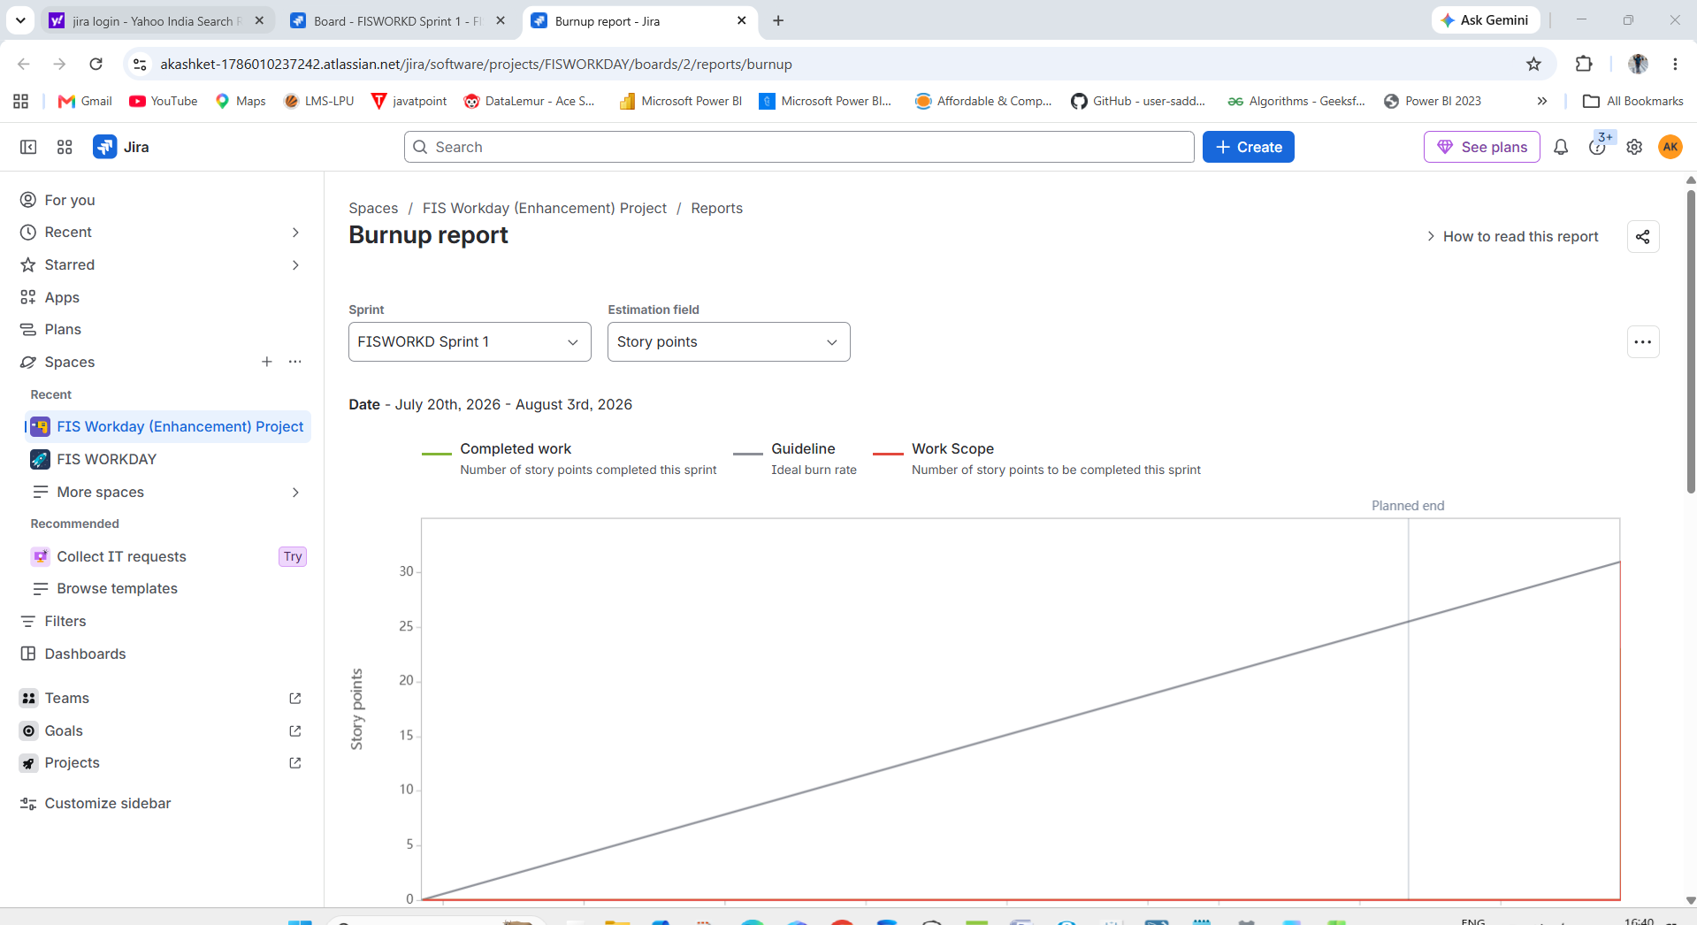

Sprint burndown
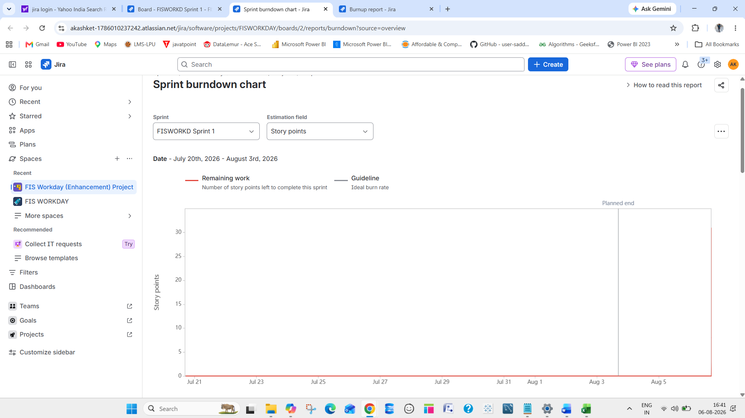

Document 6: Sprint meetings

Meeting Type 1: Sprint Planning meeting
Date | 06th July’26
Time | 11:00 AM
Location | Microsoft Teams
Prepared By | Akash Kumar
Attendees | Scrum Team (Product Owner, Scrum Master, Development Team)

Agenda Topics
Topic | Presenter | Time allotted
Welcome, Objectives, and Sprint Goal | Scrum Master | 11:00 – 11:10
Review Product Backlog & Business Value | Product Owner | 11:10 – 11:40
Select User Stories for Sprint | Development Team | 11:40 – 12:00
Estimate Effort & Capacity Planning | Development Team | 12:00 – 12:20
Define Sprint Backlog & Wrap-up | Scrum Master | 12:20 – 12:30

Other Information
Observers | Stakeholders (optional)
Resources | Product Backlog, Velocity Chart, Capacity Plan
Special Notes | Ensure alignment with business priorities; clarify dependencies and blockers

Meeting Type 2: Sprint review meeting
Date | 20th July’26
Time | 11:00 AM
Location | Microsoft Teams
Prepared By | Akash kumar
Attendees | Scrum Team + Stakeholders

Sprint status | Things to demo | Quick updates | What’s next
Completed 8 user stories, 2 rolled over | Demo for HR related automatic Job posting feature, bug fixes | Velocity improved by 10%, backlog refined | Plan for Sprint 12, focus on integration testing

Meeting Type 3: Sprint retrospective meeting

Date | 20th July’26
Time | 03:00 PM
Location | Microsoft Teams
Prepared By | Akash Kumar
Attendees | Scrum Team only.

Agenda | What went well | What didn’t go  well | Questions | Reference
Team collaboration | Daily sprint review meetings were effective | Delays in testing | How can we improve test coverage? | Sprint 11 backlog
Process improvement | Clear sprint goal alignment | Some stories lacked acceptance criteria | How to involve PO earlier? | Definition of Ready checklist

Meeting Type 4: Daily Stand-up meeting

Question | Name/Role | Week “30” (from 13-07-2026 to 17-07-2026)
 |  | Monday | Tuesday | Wednesday | Thursday | Friday | Saturday | Sunday
What did you do yesterday? | Developer 1 | Complete Login page | API integration setup | Implemented user profile API | Tested API endpoints | Fixed bugs in API responses | OFF | OFF
 | Developer 2 | Fixed UI bugs | Designed dashboard layout | Implemented dashboard charts | Integrated dashboard with backend | Polished UI and fixed minor issues
 | Developer 3 | Reviewed PRs | Wrote unit tests for login | Added integration tests | Refactored test cases | Finalized test coverage report
What will you do today? | Developer 1 | Start API Integration | Implement profile API | Test API endpoints | Debug integration issues | Prepare deployment package | OFF | OFF
 | Developer 2 | Work on dashboard | Implement charts | Connect dashboard to API | Optimize performance | Finalize dashboard for demo
 | Developer 3 | Write unit tests | Add integration tests | Refactor test cases | Improve CI/CD pipeline | Wrap up test documentation
What (if any) is blocking your progress? | Developer 1 | Waiting for test environment | Dependency on backend readiness | Minor API inconsistencies | Need QA feedback | No blockers | OFF | OFF
 | Developer 2 | Need clarification on requirements | Awaiting API endpoints | Data mismatch in API | Performance issues | No blockers | OFF | OFF
 | Developer 3 | Dependency on external library | Slow CI pipeline | Flaky test cases | Waiting for QA test data | No blockers | OFF | OFF

